Graphing Homework
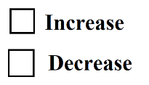  Money Market  Nominal Interest Rate | 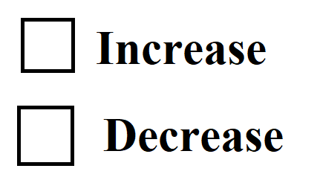  Consumption / Investment  Consumption  As a result of the _______ (higher/lower) interest rate, which _________ (lowers/increases) cost of borrowing, Consumption and Investment will:  Investment | 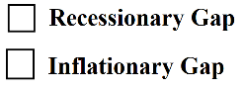  AD/AS  Expansionary Monetary Policy designed to correct a/an:
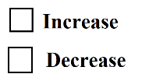  Money Market  Nominal Interest Rate | Consumption/Investment  As a result of the _______ (higher/lower) interest rate, which _________ (lowers/increases) cost of borrowing, Consumption and Investment will:  Consumption  Investment | AD/AS  Contractionary Monetary Policy designed to correct a/an:
Show the effect of expansionary and contractionary monetary policy using 3 graphs.
Contractionary Monetary Policy
Expansionary Monetary Policy

